Project Report Template

## The Tragedy of Flight: A Comprehensive Crash Analysis

BY

Team Leader : Anusiya A

Member 1 : Nagasree S

Member 2 : Sowmiya R C

Member 3 : Bhuvaneswari M

Project Record Template

INTRODUCTION

1.1 Overview

An airplane crash analysis is a detailed investigation into the causes of an aviation accident. The goal of an airplane crash analysis is to identify any factors that contributed to the accident, with the ultimate goal of improving safety and preventing future accidents. The process of conducting an airplane crash analysis typically involves the collection and analysis of a wide range of data, including information about the aircraft and its systems, the operators, and any other relevant factors. Once the data has been collected it is systems, the operators, and any other relevant factors. This data is typically collected from kaggle. Once the data has been collected it is analysed through tableau, to identify any potential causes of the accident. The results of an airplane crash analysis are typically published in a report, which may include recommendations for improving safety and preventing similar accidents in the future. These recommendations may be implemented by the relevant authorities or industry organizations.

1.2 Purpose

* Airplanes are important to the economy in various ways such as imports, exports, tourisms, and business.

* The qualities of air transport make it perfectly suited to the needs of all types of industries and companies.

*There is no faster transport service than air transport.

*An aircraft can fly to any location with seeing any natural obstacles or barriers.

Project Record Template

2. Problem Definition & Design Thinking

2.1 Empathy Map

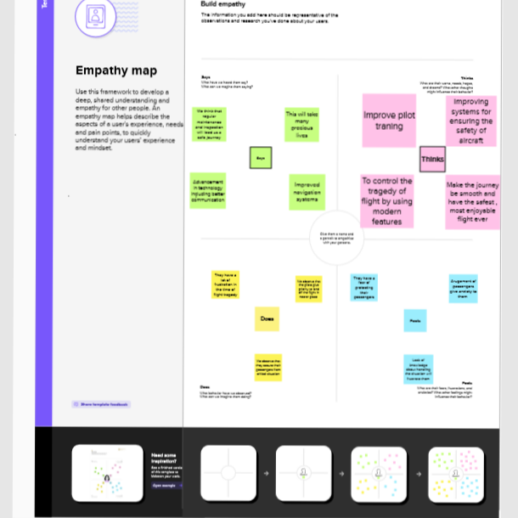

2.2 Ideation & Brainstorming Map

Project Record Template

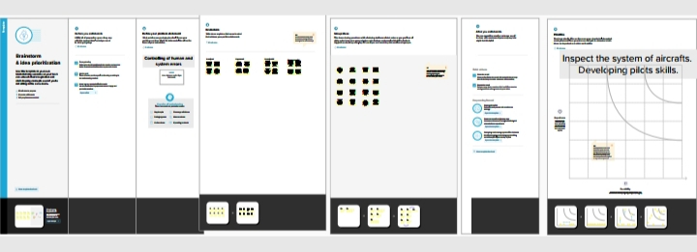

3 Result

3.1 Data Model

3.1.1 Dashboard

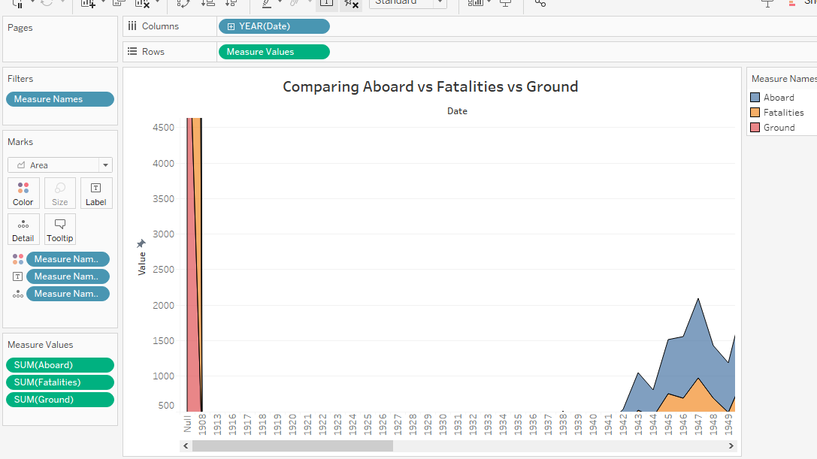

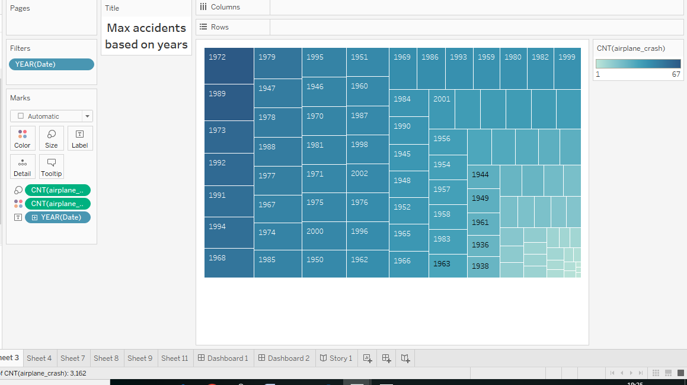

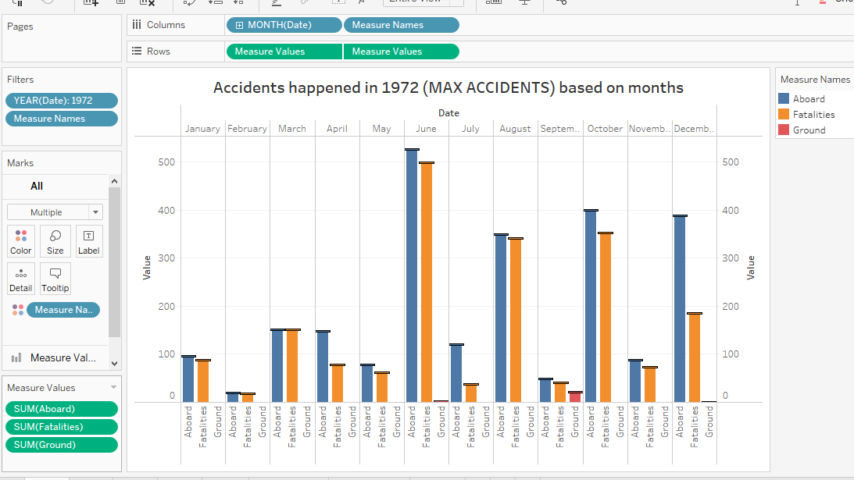

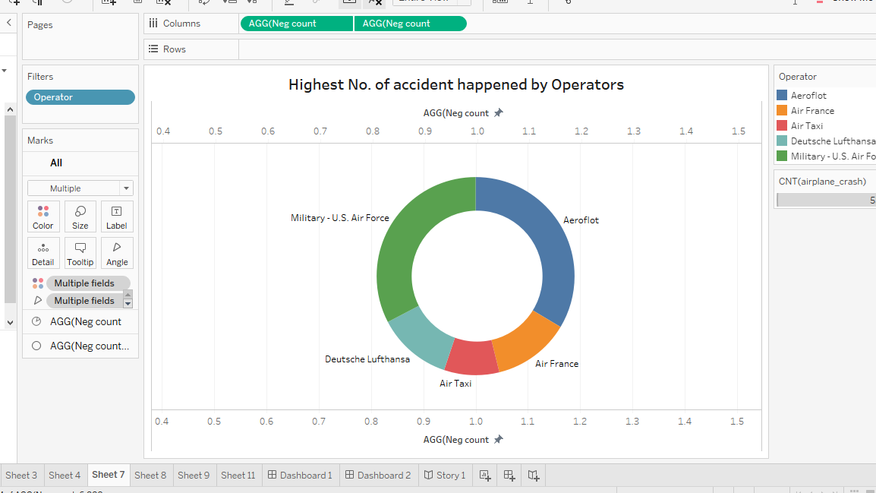

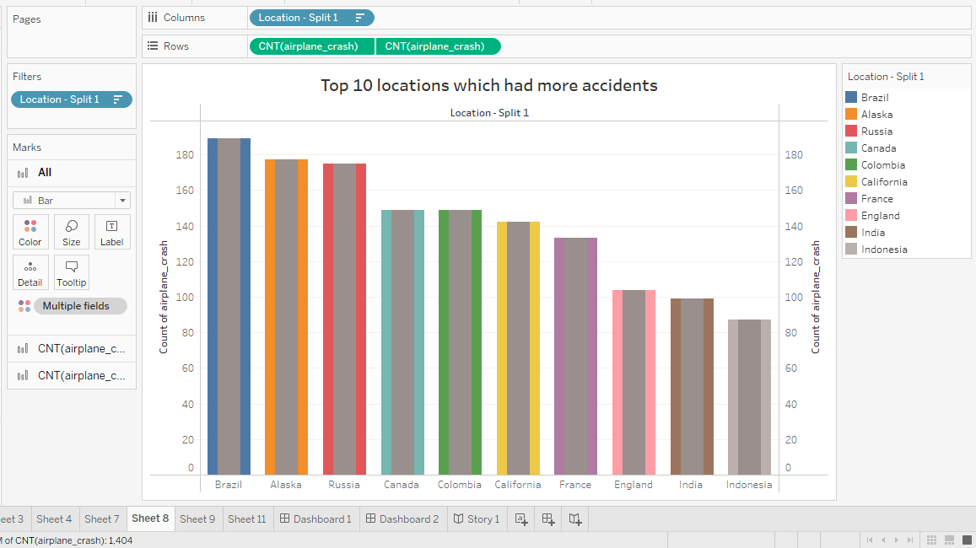

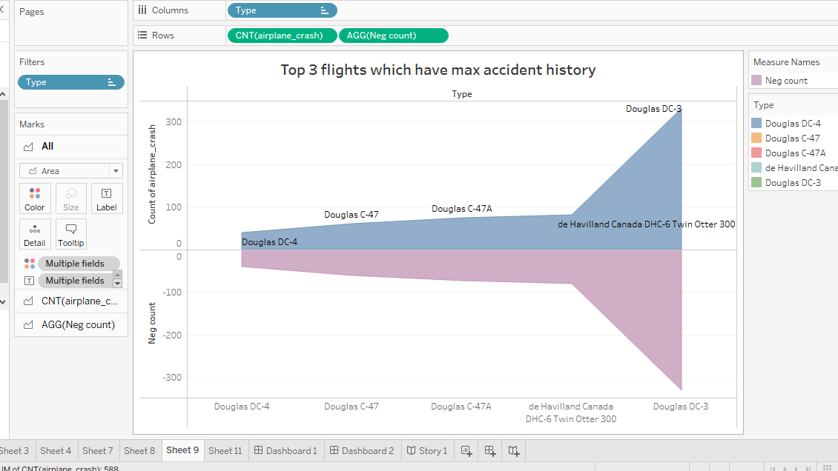

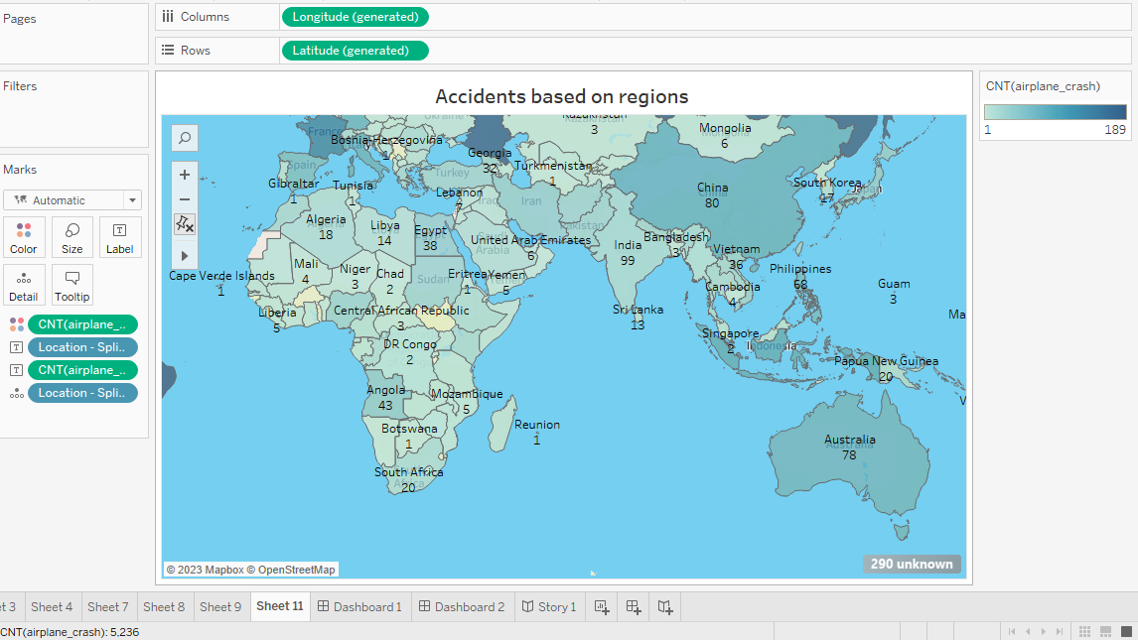

3.1.2 Story

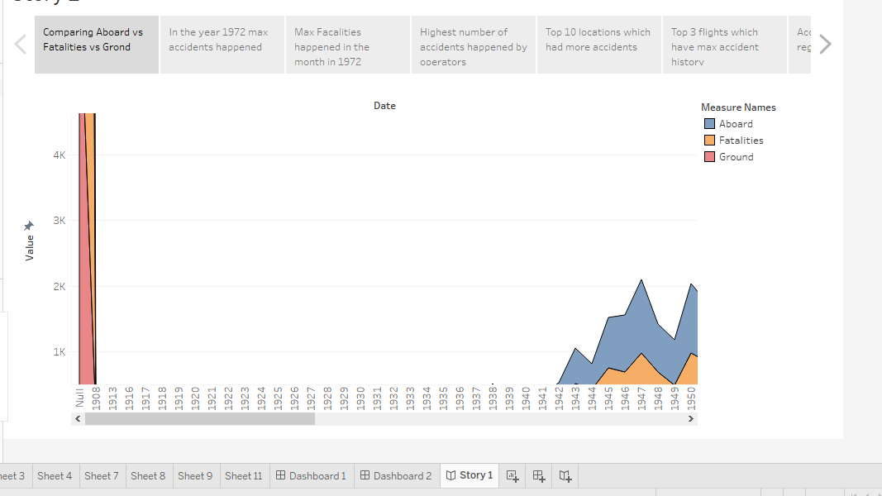

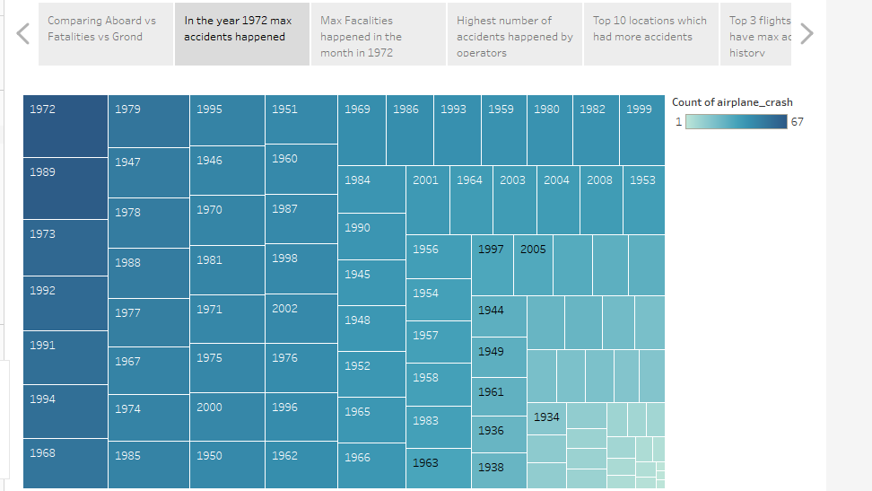

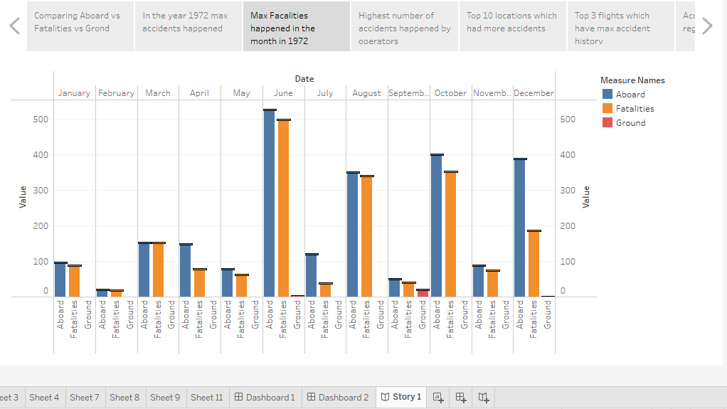

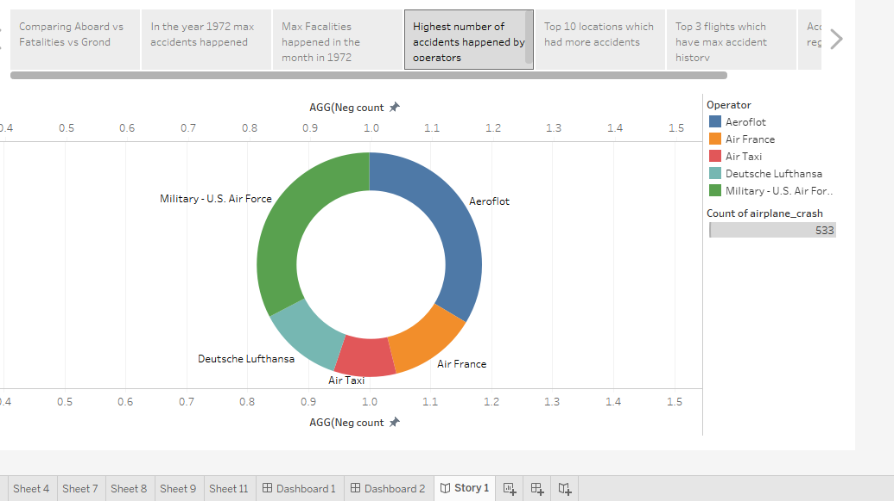

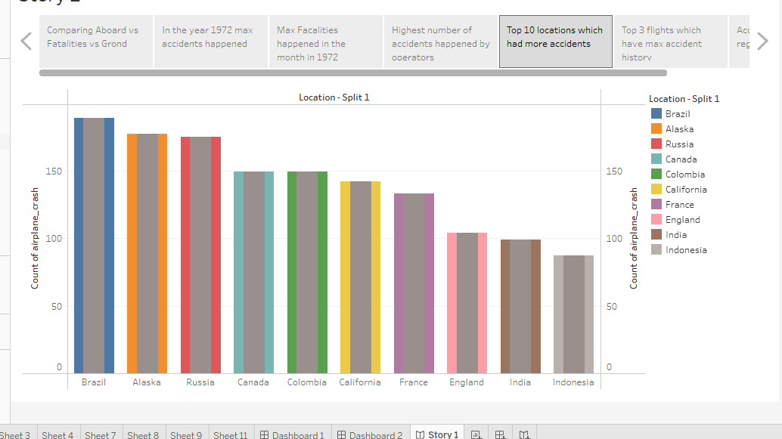

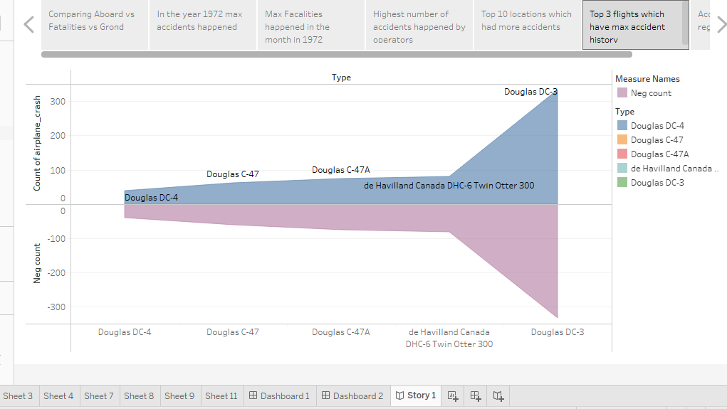

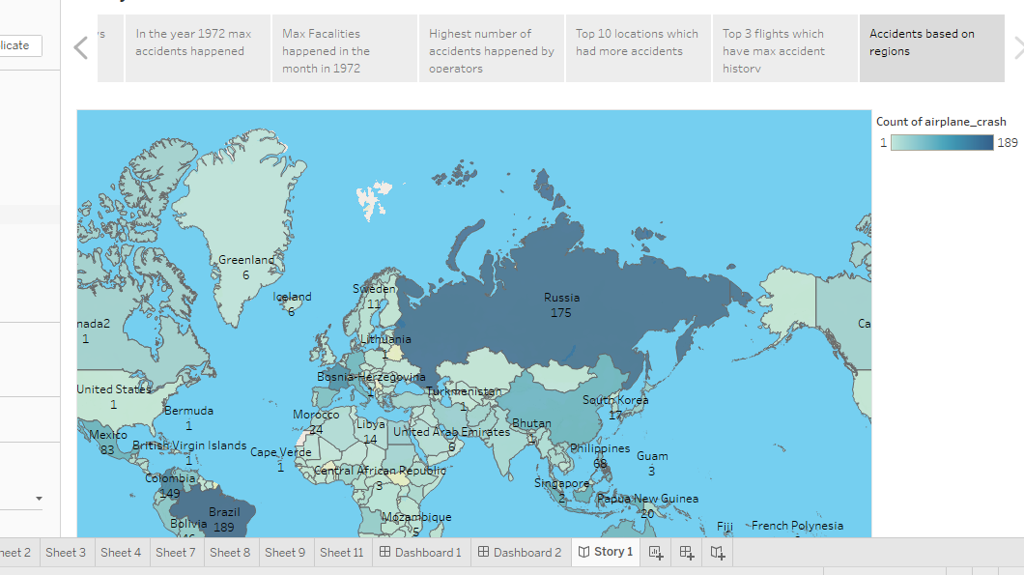

4 Advantages & Disadvantages

4.1 Advantages

• It’s the fastest & most efficient way to travel long distances.

•Air transportation offers convenient, reliable and fast services of transport. It is considered the cheapest way to ship peregrinated goods.

•A vast network of airlines covering nearly the whole globe is available for many airlines.

•Planes can carry a lot of weight.

•High standard of protection with a low risk of robbery and injury. Tightly controlled airport controls also minimize cargo theft and loss.

4.2 Disadvantages

•Air travel is the riskiest mode transport, since there can be considerable losses to goods, customer and crews as a result of a minor crash.

•The cost of maintaining aircraft is higher and the costs for the building of aerodromes and avions are much higher.

•It can be expensive depending on the route and season.

•Security measures can be inconvenient and time – consuming.

•It can be uncomfortable for long journeys. The journey can be long if you have stopovers.

5 APPLICATIONS

•Control human error

•Predict the climate

•Update the technologies

•Control death rate

6 CONCLUSION

The lot and modern technologies are advanced now a days. This advanced technology will help to control our tragedy of flight. In the case of graph, we see aboard, fatalities and ground. To reduce the tragedy of flight we have to update the technology that will reduce the tragedy.

7 FUTURE SCOPE

By developing the technology in flight people who travel by flight will be comfortable while travelling .By giving felicitous training to pilots can reduce the future tragedy in flight. So we request to implement our ideas to reduce the tragedy of flight.